1. 
2. **NOTE**: Git reset is destructive command as it removes the previous git commits.
3. **But** “git revert” is not a destructive operation.
4. **It** is safe to use as it doesn’t change the git history.
   1. **NOTE** it doesn’t change prior git history but next history in time, it will change.
5. **Application**: It reverts only one single commit.
6. **How it works**:
   1. Give a commit id.
   2. This command would revert all the changes in that commit.
   3. Then, it would create a new commit.
7. 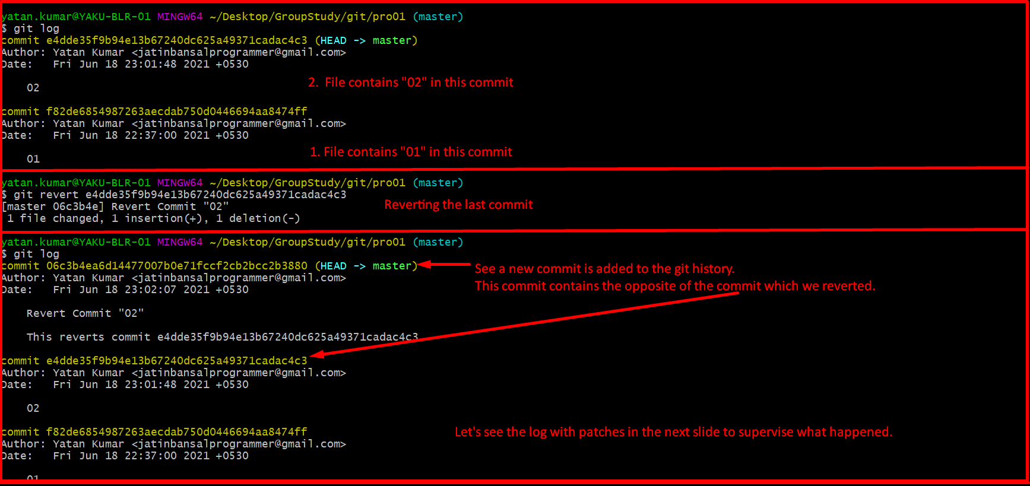
8. 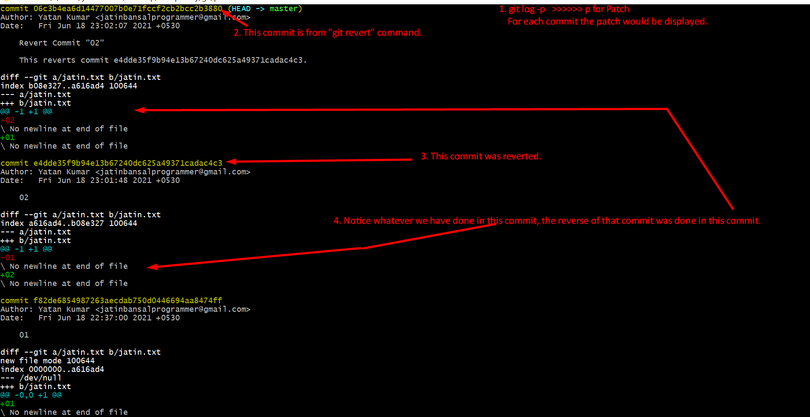
9. Difference B/w git reset and git revert
   1. “git revert” doesn’t change previous git history.
   2. “git revert” just reverts one commit.
10. Not Clear from 05:00 when trying to revert a commit which is not last commit in git commit history.